Open this URL in your browser - > <http://172.27.194.36:9100/#/register>

**If above site is not opening please follow the steps show below**:

Go to tools in Internet Explorer

Tools🡪compatibility view setting

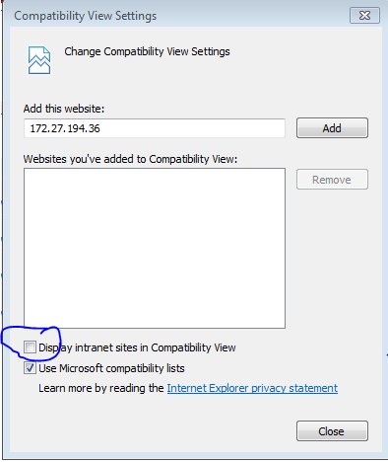

Uncheck the Display intranet sites in Compatibility view and refresh the page.

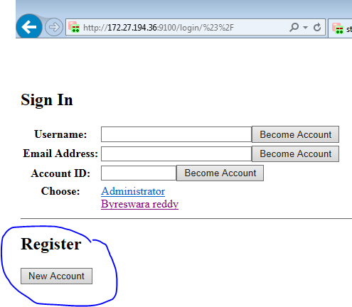

1. Click the ‘New Account’ button ( you can see in bottom of page ) .
2. Fill the details.

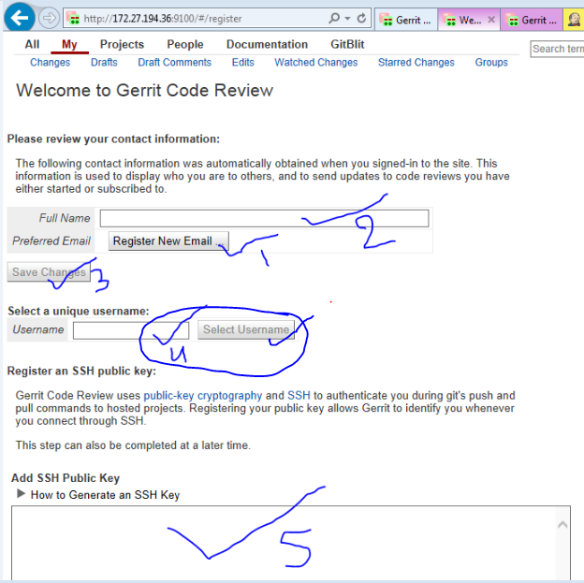

**TO ADD SSH KEY:**

Open Git-bash (in home screen click right button and select git-bash)

Enter below commands:

cd ~/.ssh (if you have not generated any key do steps in How to generate key)

cat id_rsa.pub

**HOW TO GENERATE KEY:**

cd ~

ssh-keygen -t rsa (do enter all times , so that take default values)

copy that key and paste in gerrit add SSH Public Key tab (5th option in screen shot)

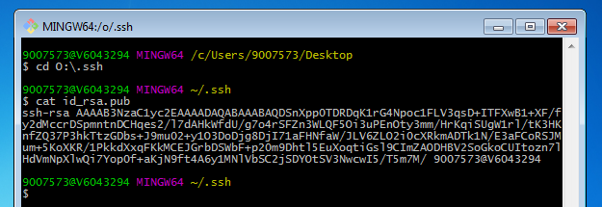

1. You should add know host s in ~/.ssh/knownhost
2. Click on copy tab (check below screen shot)

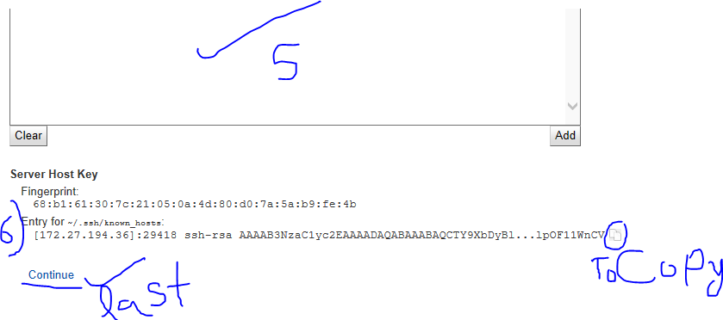

Append copied key in known_hosts file by opening that file using vim editor (follow below commands)

1. vim known_hosts
2. click “i” in keyboard to insert mode
3. right click and paste
4. click Esc button in keyboard
5. :wq

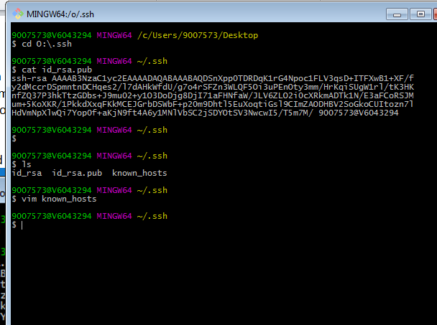

**Troubleshoot:**

How to generate Key:

For generating the key use the GIT bash which can be installed from below steps

Go to start->All Programes->Git->Git bash

Now type ssh-keygen

Hit enter for all values (it will take default values)

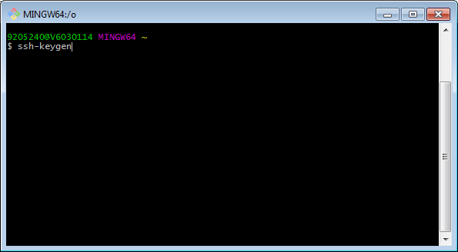

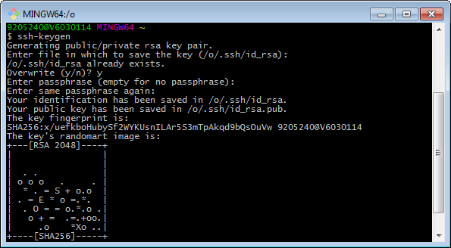

Once the public key is generated please copy the key form the path .ssh/id_rsa.pub by using the cat .ssh/id_rsa.pub command and paste in the below window, and click continue this will complete the user creation.

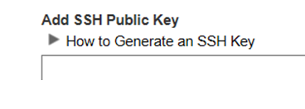

After the user is created now some of the parameter we need to change in design studio

Open design studio navigate to window-> Preferences

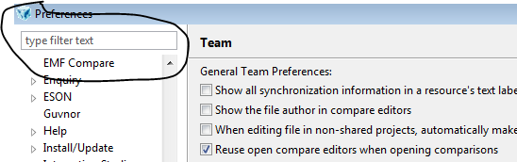

Type ssh

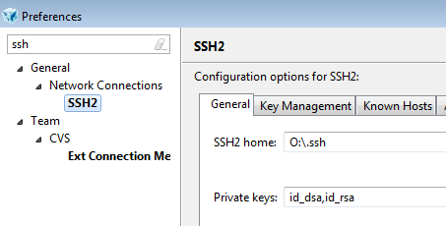

Copy the key path from the shared location and update in SSH2 home:

